**Evaluation of Clinical Pharmacist Review of Discharge Prescriptions in a Tertiary Medical Center**

Ben Chiarolanza, PharmD

Renown Regional Medical Center, Reno, Nevada

**Heather Townsend, PharmD, BCEMP, BCPS**

Renown Regional Medical Center, Reno, Nevada

Abstract:

**Background**

Medication discrepancies at discharge from the hospital have been associated with adverse drug events (ADEs). Clinical pharmacist involvement with medication reconciliation at discharge has been associated with a decrease in medication discrepancies and ADEs. In January 2023, a new process was implemented for clinical pharmacists to prospectively evaluate high-impact discharge prescriptions prior to outpatient pharmacy electronic transmission. The medications initially considered for review encompassed pediatric prescriptions (for individuals under 18 years of age), insulins, oral anticoagulants, and antimicrobials. The purpose of this study is to determine the impact of prospective review of discharge prescriptions on medication safety.

**Methods**

This quantitative study is a retrospective chart review of patients from Renown Regional Medical Center that were prescribed at least one medication that was reviewed by a clinical pharmacist on discharge from February 1st, 2023, to July 31st, 2023. Patients were excluded if they were being discharged out of the post anesthesia care unit (PACU). The outcomes to be assessed are the amount of clinical pharmacist interventions, types of interventions, percent of interventions per medication type (pediatrics, insulin, anticoagulant, antimicrobial), interventions by hospital unit at discharge, time to order verification, time from order verification to discharge and cost avoidance associated with pharmacy interventions. Time to order verification and time from order verification to discharge will only include a two-week period at the end the July. Data collection will be completed using the electronic medical record and will include: clinical pharmacist intervention documentation, prescription order, provider, hospital unit, patient age, time of prescription order, time of prescription verification, time of patient discharge. Descriptive statistics will be utilized to analyze data.

**Results**

On 24,628 qualifying discharge prescriptions there were 805 (3.3%) interventions. Antimicrobials represented 53% of the total interventions which was the highest of the four categories. Dose adjustment was the most common intervention with 415 out of the 805. The telemetry and antepartum units had the highest percentage of interventions with 16.5% and 16.2% respectively. The total cost avoidance associated with interventions was $60,803.42. Time from order to verification with interventions was 35 minutes with time from order to verification to discharge being 134.5 minutes.

**Conclusion**

Prospective discharge prescription review by an inpatient clinical pharmacist leads to more accurate dosing, less drug interactions and more appropriate treatment durations. Discharge prescription review potentially led to a significant cost avoidance without drastically increasing the daily workflow.

Keywords: include keywords here, separated by commas

1. Background

Transition from one phase of healthcare to another can put patients at risk of medication errors and adverse drug events due to loss of critical information. New medications are prescribed at discharge and courses of treatment are finished at home.1 At discharge from a hospital setting, antimicrobials are often prescribed for durations that exceed guideline recommendations leading to increased exposure and adverse effects.1 It is difficult for community pharmacists to evaluate the appropriateness of the prescription due to a lack of available patient information and access to inpatient electronic medical records.1,2

According to a study conducted by Ravn-Nielson et al., approximately 50% of the adverse drug effects leading to hospitalizations are preventable.³ In this study, 1,500 patients were divided into three groups. One group received no intervention, another group underwent a medication review, and the third group had a medication review along with three motivational interviews.³ The primary objective was to assess the impact of medication reviews on hospital readmissions³. The results showed a statistically significant difference in hospital readmissions at both the 30-day and 180-day marks between the group receiving usual care and the group with the medication review and motivational interviews.³ This study supported the use of pharmacist review of patient medications to decrease hospital readmission rates.

A similar study done in 2021 done by Uitvlugt et al. evaluated readmissions within 30 days to assess if the readmission was medication related. The study included 1,111 readmissions of which 181 were medication related. Further evaluation showed that 40% of these readmissions were preventable.2 The frequency of medication related readmissions from this study correlated with the 21% found in a 2018 systematic review.4 In this systematic review, the authors found 21% of all readmissions were due to medications.4 The categories most associated with readmissions were antidiabetic agents, diuretics, antithrombotic agents, medications for asthma/COPD.2 This study suggests that some of these medication related readmissions could have been prevented with prospective pharmacist review.

A 2023 study by Hiryak, et al. done at an academic medical center investigated the impact of prospective review of discharge antimicrobial prescriptions by inpatient pharmacists prior to the patient discharging from the hospital and the prescriptions being sent to outpatient pharmacies. Prescriptions were reviewed from 1200-1600, Monday-Friday.1 149 patients were included during the study period. Of these, 48 patients had identified errors within their discharge prescriptions leading to 55 interventions.1 The most common intervention made was recommending shorter durations of treatment1. The estimated cost saving associated with these interventions were just over $20,000.1 This study showed that interventions done before patients left the hospital led to reduced drug exposure, and cost to patients.

In order to reduce the number of medication errors associated with patient medications at discharge, in January 2023 Renown Regional Medical Center (RRMC) implemented a process to for clinical pharmacist review of discharge prescriptions. The provider would place the discharge prescription at time of placing the discharge order and the prescription order would flow to a work queue in the electronic medical record for clinical pharmacist review if the medication prescribed was either an antimicrobials, anticoagulants, or insulins or if the medication was for a pediatric patient. The clinical pharmacist would then review the prescription to assure it was appropriate for the plan of care and diagnosis, dosed appropriately, and written correctly for sig and dispense quantities. If the prescription was needed corrected or changed, the clinical pharmacist would reach out to the provider to change the prescription prior to it being sent to the pharmacy. These interventions would be documented in the EPIC iVent. Once the prescription was correct and appropriate, the clinical pharmacist verifies the prescription, and it is then transmitted to the outpatient pharmacy to be filled. The purpose of this study is to evaluate the impact of prospective clinical pharmacy review of high-risk discharge prescriptions on medication safety.

**2. Methods**

This was a retrospective chart review of qualifying discharge prescriptions from February 2023 to July 2023 at Renown Regional Medical Center. Cost avoidance was determined using the study published by Campbell and colleagues in 2011. This retrospective study evaluated interventions made by students and pharmacists and estimated the cost avoidance associated with those interventions. The cost per intervention was calculated by averaging values found in literature review plus values in their in-house cost avoidance software, Medi-trend. The cost of an adverse drug event was determined by taking the average cost of a drug event and multiplying it by a probability factor. The probability factor is the likelihood of the adverse drug event occurring in the absence of an intervention.

***2.1 Data Collection***

Data was pulled from the electronic health record including prescription data and iVent type of discharge rx review. Other data will include the discharge date, time of prescription order, prescriber information, time of pharmacist verification, time of patient discharge, discharge department, and iVent information.

***2.2 Data Analysis***

Descriptive statistics were used to analyze the data.

**3. Results**

There were 24,628 qualifying discharge prescriptions and as seen in Table 2, they are separated by hospital unit. For the primary outcome there were 805 intervention which was 3.3% of the qualifying discharge prescriptions.

Figure 2 breaks down the 805 interventions into the different types of interventions. Dose adjustment and order clarification were the two most common interventions accounting for 595/805 or 74% of total interventions. The most common interventions in the dose adjustment category were renal dose adjustments, shortening treatment durations and adding/subtracting administration instructions. For order clarification the most frequent intervention was ensuring that recommendations made by specialists (i.e. Infectious Diseases) were followed. Another common intervention was ensuring accurate transition dates for many anticoagulants ensuring the transition from loading dose to maintenance dose occurs as it should.

Telemetry, antepartum and the medical floors were the hospital units with highest percentage of interventions on their discharge prescriptions. As seen in Figure 3, telemetry had interventions on 16.5% of their total discharge prescriptions and antepartum had interventions on 16.2% of discharge prescriptions. The Medical floors had interventions on 9.6% of their discharge prescriptions. In the antepartum department a majority of the interventions were related to antibiotic choice and insulin dosing clarifications. For the telemetry and medical departments there were frequent interventions in all categories except pediatrics.

Total cost avoidance associated with interventions was $60,803.42. Dose adjustment had the highest cost avoidance at $25,490.36. Order clarification had cost avoidance of $13,003.90 and prevention of adverse drug event had total savings of $7,064.85. These interventions made up the top three for cost avoidance.

Secondary outcomes start with Figure 1 which has the 805 interventions divided into the 4 categories of medications that were evaluated. 53% of the interventions were from the antimicrobial category followed by 23% for pediatrics, 16% for anticoagulants and 8% for insulins. The 24,628-discharge prescription were divided into the four medication categories to determine what the intervention percentage is per category. Table 3 contains this breakdown; anticoagulants were the medication category with the highest percentage of interventions with 5.5%. Insulins, antimicrobials, and pediatrics were 4.8%, 4.0% and 1.8% respectively.

The time from order verification to discharge without interventions was 9.5 minutes. Time from order verification to discharge was 73 minutes when interventions were not made. When interventions were made the time to order verification was 35 minutes and order verification to discharge was 134.5 minutes.

**4. Discussion**

Over the six-month study period there were 24,628 qualifying discharge prescriptions. There were 805 (3.3%) interventions on those prescriptions. Dose adjustment was the intervention category with the most interventions. Within that category, renal dose adjustments, shortening treatment durations and administration instructions were most common. Order clarification was the next most common intervention in which ensuring compliance with specialist recommendations and ensuring accurate transition dates for many anticoagulants. This transition was often focused on transitioning from the loading dose to the maintenance dose of multiple oral anticoagulants. These interventions led to a potential cost avoidance of 60,803 dollars. As might be anticipated, prescriptions that required interventions took longer to verify. The average time on prescriptions with interventions was 25 minutes longer than on prescriptions without interventions. The increase in time, however, did not lead to an increase in time to discharge. These interventions also potentially removed any barriers or delays for prescription pick up at the outpatient pharmacy.

***4.1 Limitations***

There were some limitations associated with this study. First, not all of the interventions may have been charted by the clinical pharmacists. Second, interventions may have been mis-categorized depending on the documentation put in by the clinical pharmacists.

**5. Conclusion**

Prospective discharge prescription review by an inpatient clinical pharmacist leads to more accurate dosing, less drug interactions and more appropriate treatment durations. Discharge prescription review potentially led to a significant cost avoidance without drastically increasing the daily workflow.

Conflicts of Interest

Neither my co-investigators nor I have anything to disclose

Acknowledgements

The author may provide acknowledgements for contributions

References

1. Hiryak, K. M., Kludjian, G. A., Gallagher, J. C., & Cavaretta, M. J. (2023). Improving antibiotic utilization through an outpatient stewardship initiative. *Antimicrobial stewardship & healthcare epidemiology : ASHE*, *3*(1), e120. <https://doi.org/10.1017/ash.2022.367>
2. Uitvlugt, E. B., Janssen, M. J. A., Siegert, C. E. H., Kneepkens, E. L., van den Bemt, B. J. F., van den Bemt, P. M. L. A., & Karapinar-Çarkit, F. (2021). Medication-Related Hospital Readmissions Within 30 Days of Discharge: Prevalence, Preventability, Type of Medication Errors and Risk Factors. *Frontiers in pharmacology*, *12*, 567424. <https://doi.org/10.3389/fphar.2021.567424>
3. Ravn-Nielsen, L. V., Duckert, M. L., Lund, M. L., Henriksen, J. P., Nielsen, M. L., Eriksen, C. S., Buck, T. C., Pottegård, A., Hansen, M. R., & Hallas, J. (2018). Effect of an In-Hospital Multifaceted Clinical Pharmacist Intervention on the Risk of Readmission: A Randomized Clinical Trial. *JAMA internal medicine*, *178*(3), 375–382. <https://doi.org/10.1001/jamainternmed.2017.8274>
4. El Morabet, N., Uitvlugt, E. B., van den Bemt, B. J. F., van den Bemt, P. M. L. A., Janssen, M. J. A., & Karapinar-Çarkit, F. (2018). Prevalence and Preventability of Drug-Related Hospital Readmissions: A Systematic Review. *Journal of the American Geriatrics Society*, *66*(3), 602–608. https://doi.org/10.1111/jgs.15244
5. Campell, A. R., Nelson, L. A., Elliott, E., Hieber, R., & Sommi, R. W. (2011). Analysis of cost avoidance from pharmacy students’ clinical interventions at a psychiatric hospital. American Journal of pharmaceutical education, 75(1), 8. <https://doi.org/10.5688/ajpe7518>

**Table 1**

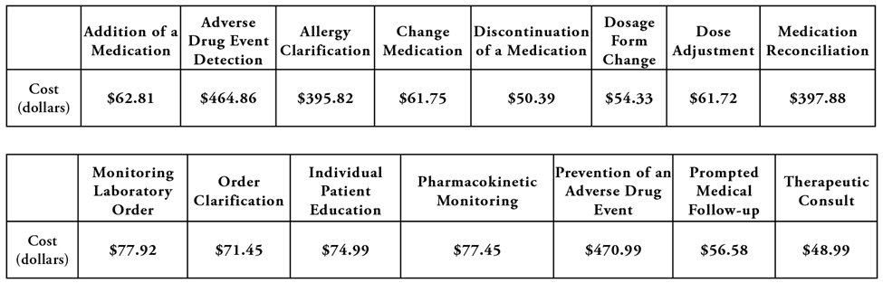

**Table 2**

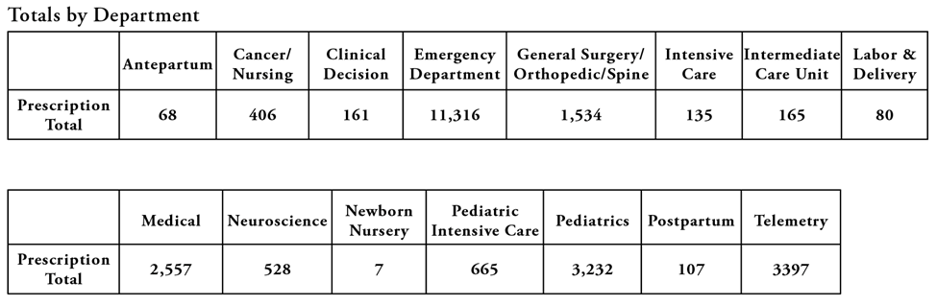

**Figure 1**

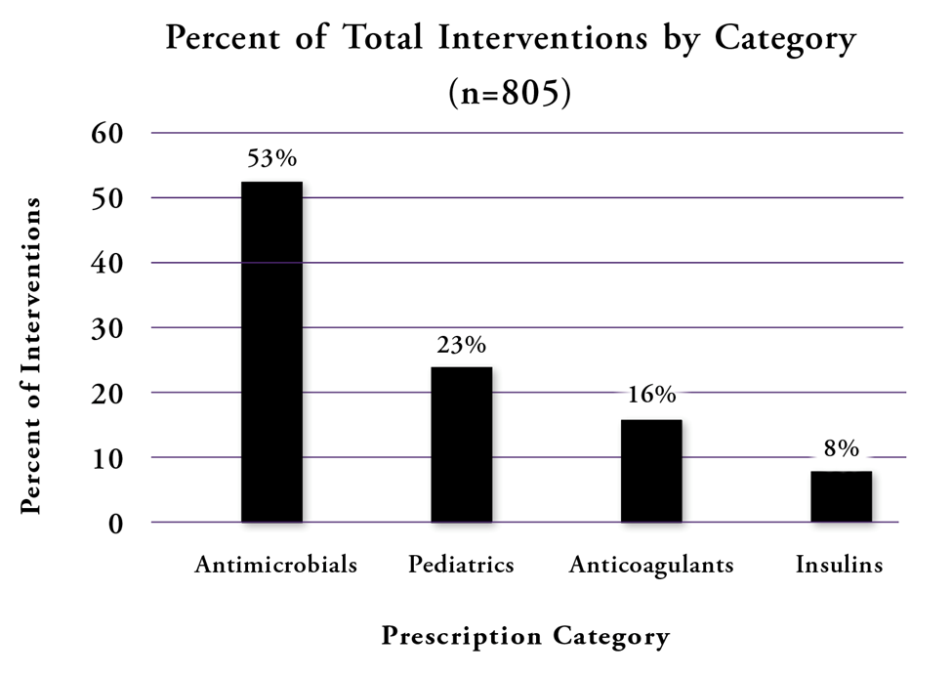

**Table 3**

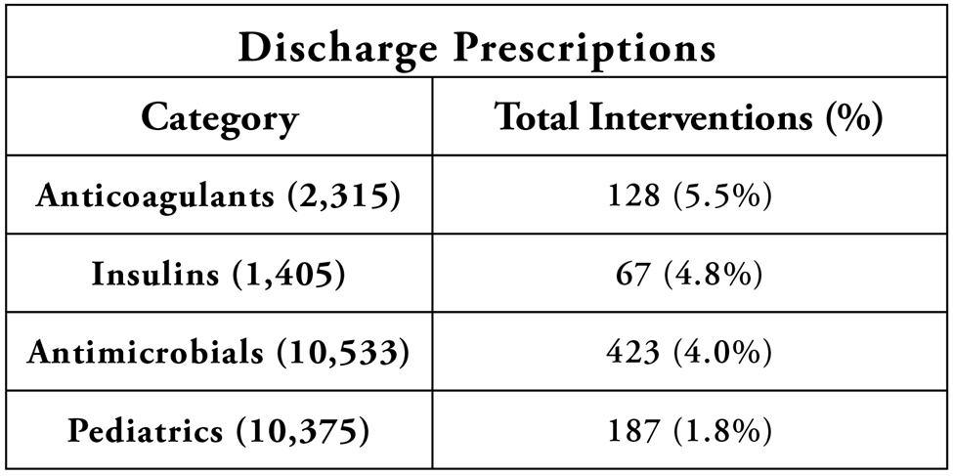

**Figure 2**

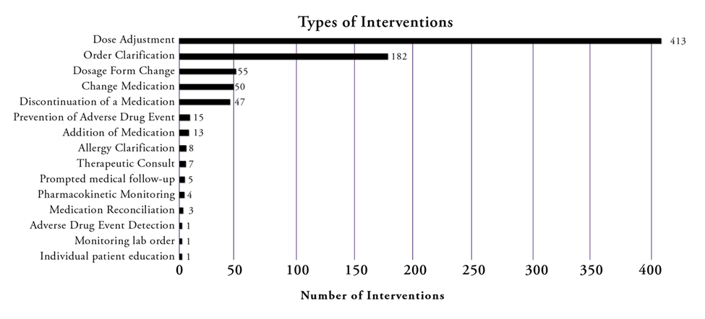

**Figure 3**

**Figure 4**

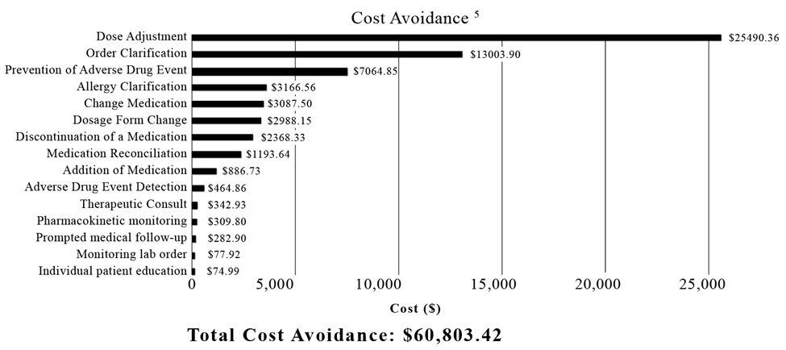

**Table 4**

