**Percentage of CABG and/or Valvular Surgery Patients Discharged on Amiodarone**

Cassandra Dilibero, PharmD

University Medical Center of Southern Nevada, Las Vegas, NV

Jaclyn Stecki, PharmD, MBA, BCCP

University Medical Center of Southern Nevada, Las Vegas, NV

Kimberly San Agustin, PharmD

University Medical Center of Southern Nevada, Las Vegas, NV

Duane Wagner, PharmD

University Medical Center of Southern Nevada, Las Vegas, NV

**Abstract**

1. **Background:** Post-operative atrial fibrillation (POAF) is the most common arrhythmic complication following cardiac surgery, with the highest incidence 48 to 72 hours post-operation. The 2023 AHA/ACC/HRS guideline on atrial fibrillation (AF) recommend beta-blockers as first-line therapy for the treatment of POAF, unless contraindicated. . Despite these recommendations and significant adverse effects of amiodarone, patients are still regularly initiated on amiodarone for management of POAF. Furthermore, amiodarone initiated while inpatient may be unnecessarily continued upon discharge. **Objective:** To identify the percentage of post-coronary artery bypass graft (CABG) and/or valvular surgery patients initiated on amiodarone at our institution and discharged home on amiodarone. **Methods:** This was a retrospective, single-center chart review of adult, post-CABG and/or valve surgery patients from July 1, 2022 to July 1, 2023. The primary outcome was the percentage of patients initiated on amiodarone at UMC post-operatively that were continued on amiodarone at discharge. Secondary outcomes included incidence of post-CABG and/or valvular surgery patients initiated on amiodarone, and use of beta-blockers post-operatively. **Results:** A total of 34 out of 100 patients were initiated on amiodarone post-operatively and 20 patients (59%) were discharged home with a new prescription for amiodarone. **Conclusion:** Our institution had a similar percentage of patients discharged on amiodarone as previous studies. More research is needed to assess the possible consequences of discharging patients on amiodarone for POAF.

Keywords: POAF, amiodarone, transitions of care

**Background**

Post-operative atrial fibrillation (POAF) is the most common arrhythmic complication following cardiac surgery, with the highest incidence 48 to 72 hours post-operation1. POAF typically resolves spontaneously within 4-6 weeks. The 2023 AHA/ACC/HRS guideline on atrial fibrillation recommend beta blockers as first line therapy for the treatment of POAF unless contraindicated2. Despite these recommendations and significant adverse effects of amiodarone, patients are still regularly initiated on amiodarone for management of POAF. Furthermore, amiodarone initiated while inpatient may be unnecessarily continued upon discharge which may lead to an increased risk of side effects, drug interactions and healthcare costs.

A single-center, retrospective study found that 59% of patients initiated on amiodarone for new-onset atrial fibrillation in critical illness were continued on amiodarone upon hospital discharge. Of those discharged home on amiodarone, 23% were done so without a referral to a cardiologist3.

The purpose of this study is to identify the percentage of post-CABG and/or valvular surgery patients initiated on amiodarone at University Medical Center of Southern Nevada (UMCSN) and discharged home on amiodarone.

**Methods**

*Study Design*

This was a retrospective chart review of adult patients who had a CABG and/or valve surgery at UMCSN from July 1, 2022 to July 1, 2023. A hospital registry of all cardiovascular surgeries during this study period was obtained to identify patients. This registry was reviewed in chronological order until 100 patients were included. Patients were excluded if they had a history of atrial fibrillation (AF) or atrial flutter, used amiodarone prior to surgery as a home medication, or if they expired or were not discharged home during they study period.

*Statistical Analysis*

The data was analyzed using descriptive statistics.

**Results**

*Study Population*

Over 300 patients were identified with the hospital registry. After accounting for procedure type, 115 patients were enrolled to be considered for inclusion and 15 of these patients were excluded. Twelve patients were excluded for history of AF or atrial flutter and 3 patients for expiring/not being discharged during the study period. This left 100 patients included in the study (Figure 1).

A majority of patients included were male (83%) and undergoing CABG (81%) with a mean age of 65 + 10.9 years (Table 1). Differences in baseline characteristics were not examined for significance.

*Study Outcomes*

The primary outcome was the percentage of patients initiate on amiodarone post-operatively and discharged home on amiodarone. Out of the patients initiated on amiodarone, 20 patients (59%) were discharged home with a new prescription for amiodarone (Figure 2). For secondary outcomes, 34 patients (34%) were initiated on amiodarone post-operatively and 86 patients (86%) of patients were started on a beta-blocker post-operatively (Table 2).

**Discussion**

During the study period, 34% of patients who underwent CABG and/or valve surgery at UMCSN were initiated on amiodarone post-operatively. Of these patients, 59% were discharged home with a new prescription for amiodarone. These findings are similar to previous studies mentioned.

Our study did have limitations. This was a small, retrospective, single-center study. Patients were identified through a hospital registry rather than via electronic health records. Lastly, we did not collect data to assess the reason for the patient being discharged on amiodarone. Due to this limitation, we are unable to determine appropriateness of continuation.

**Conclusion**

UMCSN had the same percentage of patients discharged on amiodarone as previous studies. More research is needed to assess the possible consequences of discharging patients on amiodarone for POAF. Future studies should investigate readmission rates and side effects associated with amiodarone use.

**References**

1. Atreya AR, Priya A, Pack QR, et al. Use and Outcomes Associated With Perioperative Amiodarone in Cardiac Surgery. J Am Heart Assoc. 2019;8(15):e009892.
2. Joglar JA, Chung MK, Armbruster AL, et al. 2023 ACC/AHA/ACCP/HRS Guideline for the Diagnosis and Management of Atrial Fibrillation: A Report of the American College of Cardiology/American Heart Association Joint Committee on Clinical Practice Guidelines [published correction appears in Circulation. 2024 Jan 2;149(1)
3. Leelathanalerk A, Dongtai W, Huckleberry Y, Kopp B, Bloom J, Alpert J. Evaluation of Deprescribing Amiodarone After New-Onset Atrial Fibrillation in Critical Illness. Am J Med. 2017;130(7):864-866.

Figure 1.

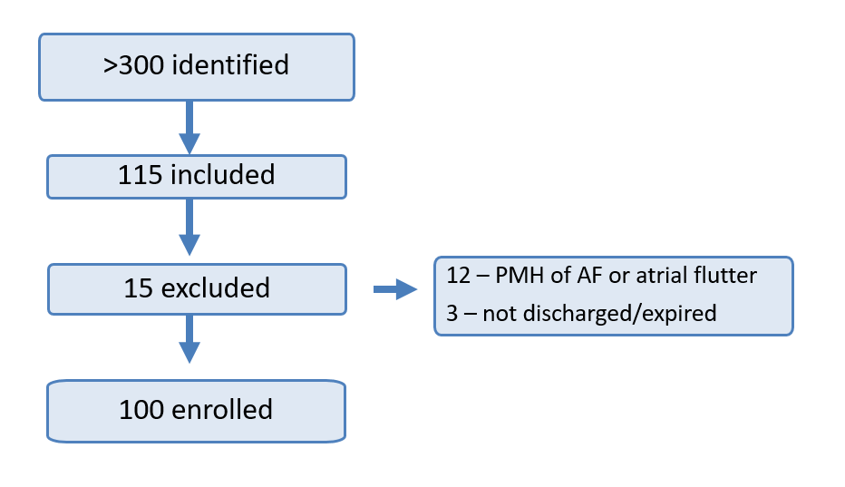

Table 1.

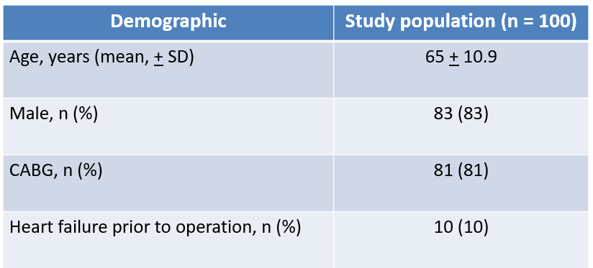

Figure 2.

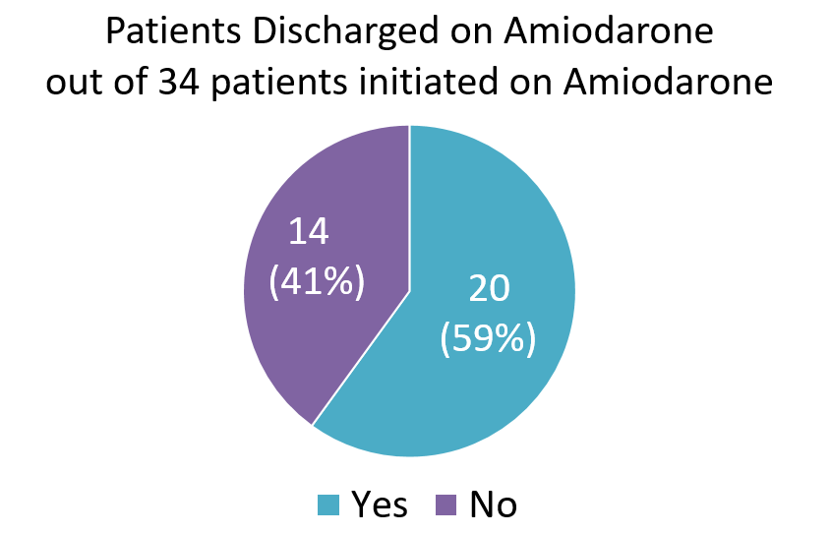

Table 2.

